H.T No
Regulations:
A22

Sreenidhi Institute of Science and Technology
(An Autonomous Institution)
Code No:9B305 Date:24 -January-2025 (FN)

B.Tech II-Year I- Semester External Examination, January-2025 (Regular & Supplementary)
MECHANICS OF SOLIDS (MECHANICAL)

Time: 3 Hours Max.Marks:60

Note: a) No additional answer sheets will be provided.
b) All sub-parts of a question must be answered at one place only, otherwise it will not be valued.
c) Missing data can be assumed suitably.
Bloom's Cognitive Levels of Learning (BCLL)

Remember | L1 | Apply | L3 | Evaluate | L5
Understand | L2 | Analyze | L4 | Create | L6

Part - A Max.Marks: 6x2=12

Answer all QUESTIONS, EACH QUESTION CARRIES 2 MARKS.

 |  | BCLL | CO(s) | Marks
1 | Draw the stress – strain curve for ductile material and mention various points. | L2 | CO1 | [2M]
2 | sketch Mohr’s circle with silent points. | L2 | CO2 | [2M]
3 | Compare simply supported beam and cantilever beam. | L2 | CO3 | [2M]
4 | Write the general Bending stress equation. | L2 | CO4 | [2M]
5 | State steps in Macaulay’s method. | L2 | CO5 | [2M]
6 | Write the Lame’s equations for thick cylinder. | L2 | CO6 | [2M]

Part – B Max.Marks: 6x8=48
ANSWER ALL QUESTIONS. EACH QUESTION CARRIES 8 MARKS.

 |  | BCLL | CO(s) | Marks
7. | A circular steel bar ABCD, rigidly fixed at A and D, is subjected to axial loads of 50 kN and 100 kN at B and C, as shown in Figure below.  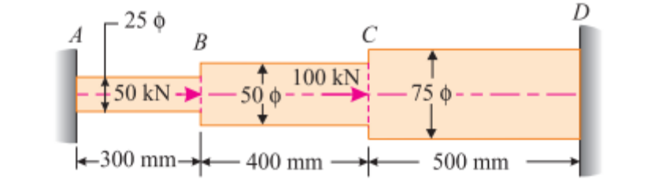 | L3 | CO1 | [8M]
 | OR
8 | A steel tube of 100 mm external diameter and 500mm length is subjected to 10kN load. Calculate tensile stress and strains(longitudinal and lateral).Take E =200 GPa | L3 | CO1 | [8M]
9. | The stresses at a point in a component are 100 MPa (tensile) and 50 MPa. (compressive). Determine the magnitude of the normal and shear stresses on a plane inclined at 25° with tensile stress. Also, determine the direction of the resultant stress and the magnitude of the maximum shear stress intensity. | L3 | CO2 | [8M]
 | OR
10 | A solid steel shaft must transmit 8kN-m. Determine the suitable diameter of the shaft. The shear stress is not to exceed 70N/mm². Also, calculate the maximum angle of twist in a length of 4m of the shaft. G=80Gpa | L3 | CO2 | [8M]
11 | Draw shear force and bending moment diagrams for the following diagram.  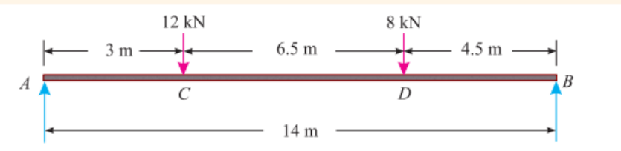 | L3 | CO3 | [8M]
 | OR
12 | A cantilever 1.5 m long is loaded with a uniformly distributed load of 2 kN/m run over a length of 1.25 m from the free end. It also carries a point load of 3 kN at a distance of 0.25 m from the free end. Draw the shear force and bending moment diagrams of the cantilever. | L3 | CO3 | [8M]
13 | A wooden beam 150 mm × 50 mm rectangular section subjected to a moment of 6.4 kN-m is applied around the horizontal neutral axis, inducing tension below the neutral axis, find the bending stresses at both the extreme fibers of the cross-section. | L3 | CO4 | [8M]
 | OR
14 | A rectangular section beam of(120mm x 20mm) is subjected to a shear force of 60kN. Draw the shear stress distribution and calculate maximum shear. | L3 | CO4 | [8M]
15 | A simply supported beam AB of span 5 m carries a point load of 30 KN at center Calculate the slopes at A and B and deflection under the load. Take EI = 26 × 10¹² N-mm². | L3 | CO5 | [8M]
 | OR
16 | Derive the equation for the slope and deflection of a cantilever Beam with a point load P at free end. length of a beam is L. | L2 | CO5 | [8M]
17 | A cylindrical thin drum 80 cm in diameter and 3 m long has a shell thickness of 1 cm. If the drum is subjected to an internal pressure of 2.5 N/mm², determine (i) Hoop stress (ii) change in volume. Take E= 2x10⁵ N/mm² Poisson’s ratio 0.25. | L3 | CO6 | [8M]
 | OR
18 | Determine the hoop stress across the section of a cylindrical pipe of 400 mm internal diameter and 600 mm outer diameter, when the pipe contains a fluid at a pressure of 8 N/mm². Also sketch hoop stress distribution across the section? | L3 | CO6 | [8M]

-- 00 -- 00 –

